http://www.openminds.tv/french-ufo-report-081610/

New French aerospace report endorses reality of UFOs
Antonio Huneeus | Aug 16, 2010 | 7 comments

AAAF Logo
A new French report released on May 31, 2010 concluded that UFOs are definitely real and possibly of extraterrestrial origin. While not an official government study, the Progress Report of the Sigma/3AF Commission comes from a highly credible source, the Aeronautical & Astronomical Association of France, known as the 3AF, which established a Commission on Unidentified Aerial Phenomena back in May 2008. The Commission’s President is Alain Boudier, a former French Defense attaché, and one of its key members is Jean-Gabriel Greslé, a former fighter pilot who studied at the U.S. Air Force Academy and later became an airliner pilot with Air France, where he experienced a couple of UFO sightings. Greslé has published three UFO books in France, including Unidentified Flying Objects: An Airline Pilot Talks (Guy Trédaniel, 1993).

Alain Boudier, President of the Sigma/3AF Commission (image credit: ovni-alerte.com)
The Sigma/3AF is not a final report but just a work in progress document; nevertheless, it provides good background material on the history of official UFO research in France, a balance of Sigma’s work during the last two years, a brief description of the most significant French cases, and some comments and conclusions. The report begins with a brief history of French official UFO research, which is quite extensive: “France is the only country where the collection of Unidentified Aerospace Phenomena (PAN in French) and its scientific study have been assigned since 1977 to a civilian official organization, the CNES (National Center for Space Studies, the French space agency) through the GEPAN study group.” After a short description of this unit, now known as GEIPAN (Study and Information Group on Aerospace Unidentified Phenomena), the report outlines other official or quasi-official French studies, including the famous COMETA (Committee for In-Depth Studies) Report of 1999, issued by a group of high-ranking retired French military and intelligence officers, which concluded that UFOs were real and probably extraterrestrial.
Members of the Sigma/3AF Commission also met representatives of many other official French military and intelligence organizations that had some UFO involvement in the past. These included the National Gendarmerie, which has collected UFO reports systematically since the 1960s; the General Secretariat of National Defense, which issued an interesting report a few years ago (although I am not aware that it was ever released to the public); the Air Force; and one of France’s intelligence services, the General Directorate for External Security, which admitted through an “authorized source” that UFOs have been monitored by the agency since the early sixties.
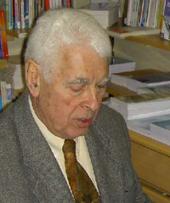
Retired fighter and airliner pilot Jean-Gabriel Greslé, a key member of the Sigma/3AF Commission. (image credit: Les Repas Ufologiques)
The section on “the most significant French cases” provides a very short description of five incidents: a massive multiple-witness sighting in Madagascar in 1954; the famous landing and Close Encounter of the Third Kind (CE-III) in Valensole in 1965, which was documented by the Gendarmerie; the equally famous landing case in Trans-en-Provence in 1981, and another similar one in Nancy in 1982 known as “amaranth,” both of which were investigated by GEPAN and published respectively in their Technical Notes Nº 16 and Nº 17. The last case is a multiple-witness sighting seen in a diagonal between Biarritz and Strasbourg across France in November 1990.
A REAL AND NON-TERRESTRIAL PHENOMENON
In the Comments section, the Sigma/3AF report uses unambiguous language, for instance: “No natural phenomenon can account for the majority of observation reports accompanied by electromagnetic detections made by one or several radars. Both the defense services and air traffic control have been confronted a number of times around the world with unknown aerial intrusions or artificially induced phenomena.” Later on, the report goes on to say, “The behavior of these devices during encounters with fighter jets or interceptors – some have participated in real swirling battles in the U.S. – suggests they are controlled, guided or led by particularly sophisticated automation.” And then again, “the air superiority of the craft concerned, if they are indeed crafts, is such that none of the many interceptions which have been made against them, in the United States for example, have been able to overcome one of these devices.”
After outlining a number of characteristics exhibited by UFOs, such as “remarkable accelerations of the craft right after a stationary mode,” the report indicates: “We feel that we must reject the thesis of a terrestrial origin for all the observations made since World War Two. Indeed, if a nation of the world had been able to secretly develop such an armada of exotic craft, like those observed for more than half a century, the means of analysis and strategic logistics available would have permitted their rapid identification. The illegal overflights which they have been guilty of conducting could constitute a casus belli [cause for war].” The Sigma/3AF experts go on to state that, “the above features suggest that in many cases the devices detected, far from being unidentified, are easily recognizable by the aerial defense agencies as part of a technology far ahead of ours.” And later: “We have been unable to get any serious indication as to the origin of the aerospace phenomena that is the subject of our research. The technological elements that we selected… allow us to draw some assumptions about the aircraft in question, which do not seem to belong to an identifiable terrestrial technology at the times when they were observed.”
The Sigma/3AF report finally agrees with COMETA’s conclusion that we are probably facing an ET presence. That conclusion was quite controversial for a semi-official study like COMETA back in 1999 and was criticized by many in the French press. Yet the Sigma/3AF Commission found no quarrel with it. “Thus, the central hypothesis proposed by the COMETA report still cannot be rejected up to this day and remains perfectly credible,” they wrote. “Many documents and materials examined by the authors of this report confirm it. We have therefore retained, among some others but only as a working hypothesis, the possibility that most of the craft observed can have a non-terrestrial origin.”
The original French text of the Sigma/3AF report can be downloaded in pdf here.
The English translation of the full Sigma/3AF report can be downloaded in pdf here.
The website of the Sigma/3AF Commission (in French) can be found here.
A good French biography of Jean-Gabriel Greslé with a description of his UFO sightings as a pilot can be found here.
A description of the 1954 mass UFO sighting in Madagascar is available in the complete French ufologie.net website here.
A short description of the 1965 Valensole CE-III with links to several newspaper articles about it, also from ufologie.net, here.
The 1981 Trans-en-Provence UFO landing case (with some info on the 1982 “amaranth” case as well) from the UFO Briefing Document – The Best Available Evidence (the report funded by Laurance Rockefeller of which I was co-author) is available here.
The complete Technical Notes Nº 16 and Nº 17 on the Trans-en-Provence and Nancy cases (as well as numerous other official reports, all in French) from the official GEIPAN website here.
An English translation of the full 1999 COMETA Report here.
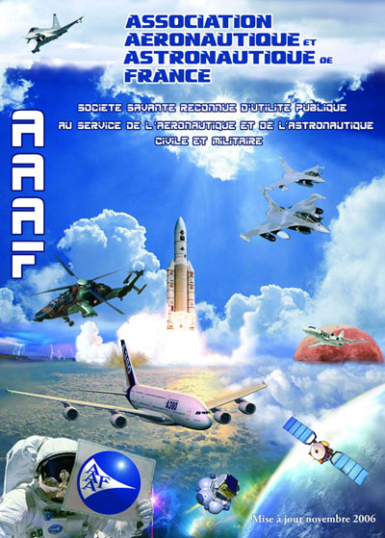
Poster of the Aeronautical and Astronautic Association of France (3AF) (image credit: 3AF)
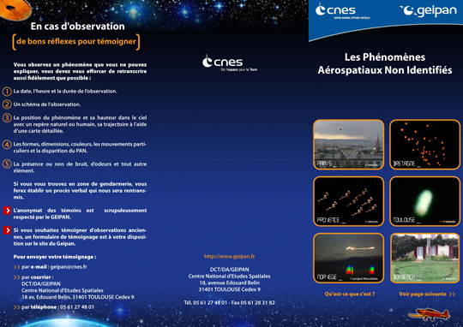
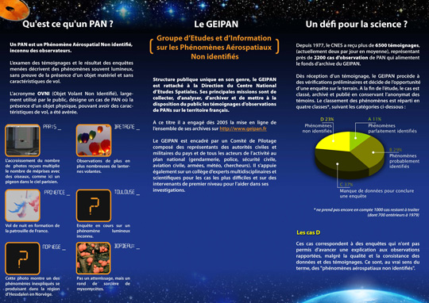
Information chart of GEIPAN of what to do if you see a UFO and some basic definitions. (image credit: GEIPAN/CNES)
Share and Enjoy:
Filed Under: Articles • Featured
Tags: 3AAF, Aeronautics, Aerospace, Alien, Extraterrestrial, Featured, france, French, GEIPAN, UFO
If you enjoyed this article, subscribe to receive more great content just like it.
Subscribe via RSS Feed


About the Author
Open Minds Investigative Reporter J. Antonio Huneeus has covered the UFO field from an international perspective for over 30 years. His articles have appeared in dozens of publications in the U.S., Latin America, Europe and Japan. He was also the co-author of the Laurance Rockefeller-funded “UFO Briefing Document – The Best Available Evidence” and edited the book “A Study Guide to UFOs, Psychic & Paranormal Phenomena in the USSR.” Huneeus studied French at the Sorbonne University in Paris and Journalism at the University of Chile in Santiago in the 1970s. He has lectured at dozens of UFO Conferences all over the world and been interviewed by many media outlets including The Washington Post, the Sy-Fy and History Channels, Nippon-TV, etc. He received the “Ufologist of the Year” award at the National UFO Conference in Miami Beach in 1990 and the “Courage in Journalism” award at the X-Conference in Gaithersburg, Maryland, in 2007.

Comments (7)
Trackback URL | Comments RSS Feed
- John Novak says:
August 18, 2010 at 10:45 am
If the French would look in their own and other countries patent offices, they’d find a mountain of evidence pointing towards the source of most UFOs. ufohowto.com proves we have the technology!
- Rufus says:
August 22, 2010 at 11:33 pm
I wouldn’t trust the French if they concluded that the sky was blue and we need oxygen to survive. They are complete morons.
- ZOIS says:
August 24, 2010 at 7:01 am
RUFUS WHO WOULD YOU TRUST THE AMERICANS. YOUR THE MORON
THE WHOLE WORLD KNOWS UFOS ARE REAL. FOR THE LAST 35 YEARS THE US HAS DUMBED DOWN THERE KIDS AS NOT TO ASK QUESTIONS AND TO FALL IN LINE WITH WHATEVER THE GOVERMENT SAYS IS TRUE. JUST LOOK AT 911 WAKE UP BEFORE YOUR DEAD
- KENNETH BOWRY says:
August 24, 2010 at 5:13 pm
Rufus you must be an agent for the US Goverment,poor americans are so stupid they dont read just watch TV all day.UFO are real they have been coming here for over Forty Thousand years,just read the Veda’s.
- Samuel Walter says:
August 24, 2010 at 6:22 pm
John Novak: Your assertion that conventional, prosaic craft and technologies are responsible for “most UFOs” is completely baseless and is, in fact, a perfect example of research by proclamation. How is that you know the source of what hundreds of thousands of people in every country have seen and experienced? If you’re going to make a statement as ubiquitous and all-encompassing as you have, you need to back it up with facts if you don’t want to look like a complete fool. The website you reference, ufohowto.com, is nothing but a collection of submitted patents selected for the purpose of filling the website owners pockets with money. It’s obvious that you don’t understand what a patent even is. A patent doesn’t prove the existence of anything; it is merely the formal outline of a hypothesis or idea. There are patents for all types of things which look great on paper but have no basis in reality or practice. Please, do us all a favor and THINK before you write. Nobody benefits from reading your uneducated drivel.
- jon says:
August 26, 2010 at 7:15 am
just one more of the thousand steps set for disclosure. Our Time Is Coming ! thanks Dr. Steven Greer.
- Dave Oblad says:
August 26, 2010 at 8:06 pm
Zero Point Energy can be gathered using a ZPM composed of alternating layers of a semi-conductor, not unlike that used for Diodes, coated on an atom thin ceramic that serves to destabilize space-time fluctuations. Each layer is barely an atoms thickness. Positive and Negative energy (electrical) is captured and routed to terminals for use, like a battery that never discharges. This energy can be transmitted, using electron spin entanglement, to where it’s needed.. thus no wires are required.
The biggest power draw is from the Quantum Computer, which has an iron core that’s entangled with external iron mass. The computer allows you to manipulate this external mass like putty.
Gravity is not a pulling force. It is a Field of space-time with variable density, sometimes mistakenly called Dark-Matter. Ordinary Matter travels/claws towards greater density by reason of it’s probabilistic motions.
The quantum computer can tip this probability motion to force the atoms to move/claw in any direction one chooses, including towards lesser field density or also what is commonly called “UP”. One cubic inch of entangled iron has the lifting capacity of about 1 ton in our gravity field.
These are the basics for building a simple flying saucer. Only a handful of people (humans) know this information at this time. Research along these lines is strictly controlled and discouraged by the general academics. Quantum controlled matter can do a lot of other things besides just fly, including Nano-Technology, pseudo Force Fields, Armor, Kinetic Weapons etc.. (to name just a few) and has massive military potential. Free energy could really mess up this worlds economics and the military advantages could be horrible in the wrong hands.
If you don’t believe any of this.. copy and paste this comment into a saved document. Come back and read it again in a decade or so.
Have a great day everyone.
Dave :^)

Leave a Reply

Haut du formulaire
Name (required)
Email (required) (will not be published)
Website
If you want a picture to show with your comment, go get a Gravatar.

Bas du formulaire

